Smart Underwriting Workbench — Demo Guide

The Smart Underwriting Workbench is an agentic AI solution that automates insurance submission processing. A broker sends
an email with ACORD forms → the AI agent autonomously classifies, extracts, scores, prioritizes, and assigns the
submission — all within 3 minutes, with zero manual intervention.

Dashboard URL: https://uw.hcp.virtusa.dev/

Pre-Requisites:

- Browser: Chrome (recommended)
- Email access: Gmail account configured with Apps Script (Currently Pravin & Arasan)
- Sample ACORD documents: Acord125 + Acord140 PDFs
- Internet connectivity to access the dashboard

Step 1 — Send the Email (Mimicking a Broker)

Open Gmail and compose a new email:

To: pravinvp@virtusa.com (or whichever email has Apps Script configured)
Subject: [UW-INTAKE] Commercial Property - Apex Manufacturing
Body:

Hi,

Please find the ACORD forms for Apex Manufacturing Corp attached.
Effective date: 06/01/2026. Sum insured: $4,000,000.
Please review and quote.

Broker
Marsh McLennan

- Attachments: Attach Acord125_Sample_A.pdf and Acord140_Sample_A.pdf

Click Send.
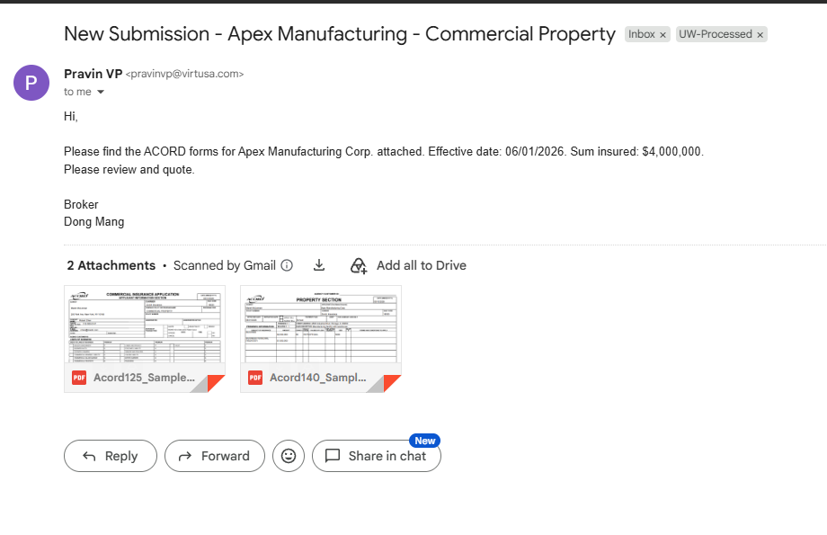
Step 2 — Open the Dashboard

Navigate to: https://uw.hcp.virtusa.dev/

You will see the main dashboard with:
- Total submissions count
- Assignment status breakdown
- Priority distribution chart
- Sum insured total & Average risk score

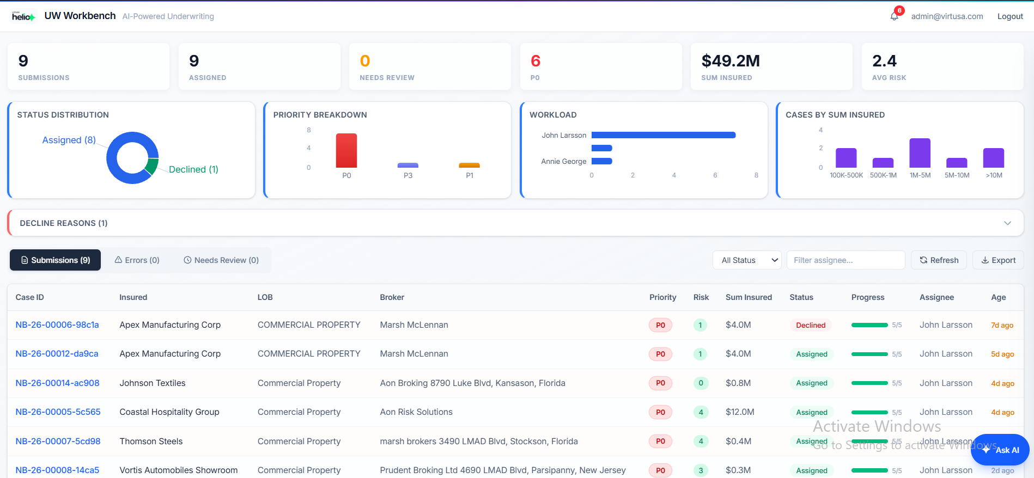

Step 3 — Watch the Case Appear

Within 30-60 seconds of sending the email, the system automatically:
1. Detects the email
2. Downloads the attachments
3. Uploads to cloud storage
4. Triggers the AI agent

A new case will appear in the submissions list with status "Processing" or "Classification".

Click the refresh icon or wait for auto-refresh.

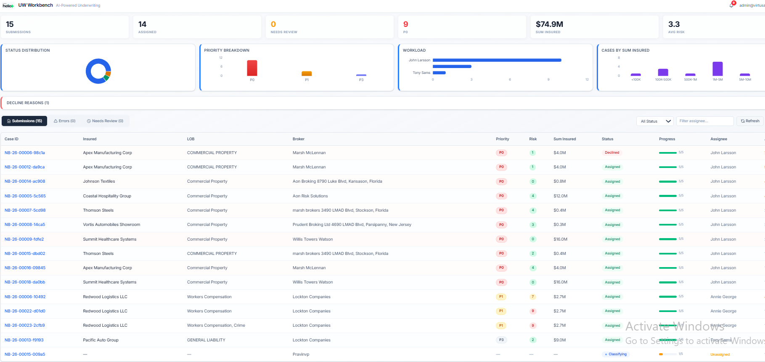

Step 4 — View Agent Logs (Live Processing)

Click on the new case to open the detail view. Select the Agent Logs tab.
You will see the AI agent's reasoning chain streaming in real-time:
Each tool invocation is visible with timestamps.
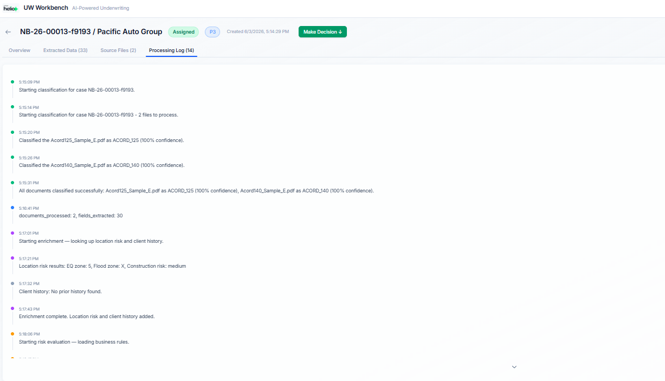

Step 5 — Review Extracted Data

Once processing completes (approximately 2-3 minutes), navigate to the Details tab.

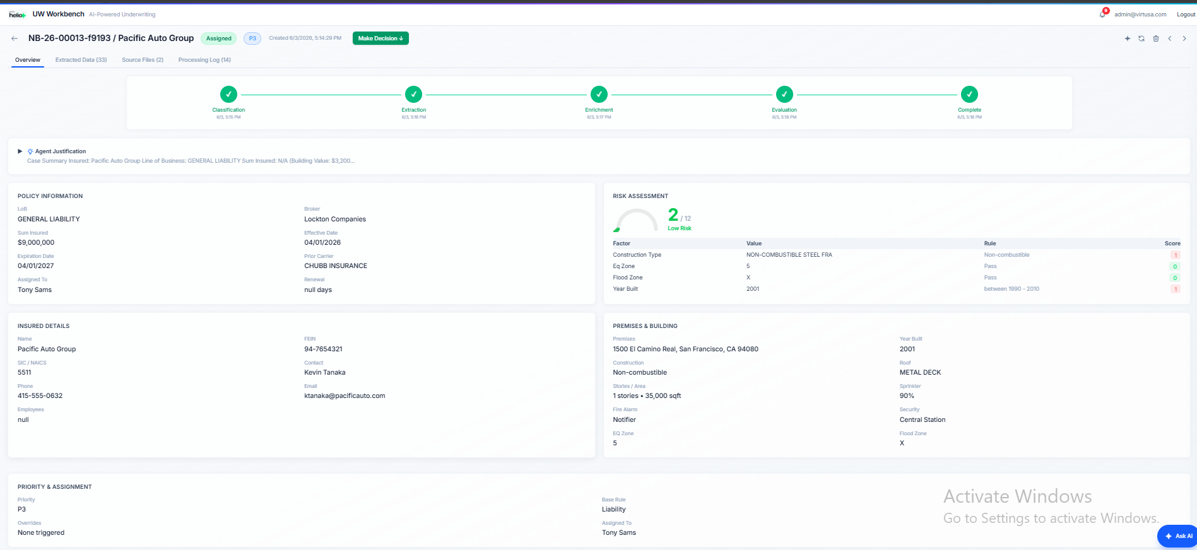

Step 7 — Accept or Decline

Click the Accept or Decline button to make the final underwriting decision.
The agent recommends — the underwriter decides. This is human-in-the-loop design.
After accepting, the case status changes to "Complete".

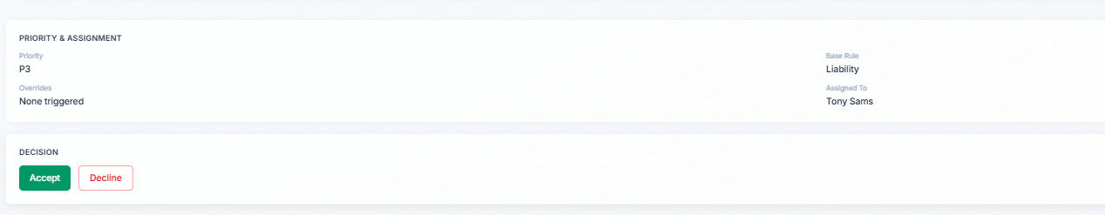

Step 8 — Chat Agent (Conversational AI)

PROMPTS :

What are my submissions?
Ok, Am John , Which submission should i start with today ?
Why should i start with the recommended case? Why not others ?
Can you show me the details of the case then
Can you provide the 360 degree justification for this case?

Summary of the Demo Flow

| Step | Action | What Happens |
|------|--------|--------------|
| 1 | Send email | Broker submits ACORD forms |
| 2 | Open dashboard | See current portfolio state |
| 3 | Wait 30-60s | New case appears, agent starts processing |
| 4 | Agent Logs | Watch AI reasoning chain live |
| 5 | Details tab | Review extracted & enriched data |
| 6 | Risk section | See score, priority, recommendation |
| 7 | Accept/Decline | Human makes final decision |
| 8 | Chat agent | Ask questions, get intelligent answers |

